

Draw Insights from Marketing Data

UDACITY 2ND PROJECT



omnia al asfoor

Setting Goals:

* Identify Key Business Objectives:

Crucial Business Goals:  
15% more conversions on websites in six months  
More specifically: Increase the proportion of visitors to the website who buy something.  
Conversion rate rise of 15% is measurable.  
Realistic: Through enhanced CTAs, promotions, and UX enhancements.  
Significance: Has a direct effect on revenue and sales.  
Time-bound: Must be completed in six months or less.  
In just 12 months, increase monthly online revenue by $25,000.  
Target: Increase overall revenue from online sales.  
Measurable: An extra $25,000 in monthly income.  
Realisable: By means of focused advertising and well-optimized product listings.  
Relevant: A fundamental objective of any online retailer.  
Time-bound: Finish the project within a year.

In the next four months, increase mobile traffic by thirty percent.  
Particulars: Increase the store's mobile user base.  
Measurable: a 30% increase in mobile device visits.  
Achievable: Through social media promotion and mobile-friendly design.  
Relevant: The bulk of users are frequently mobile traffic.  
Time-bound: Must be accomplished in four months.  
In six months, cut the rate of shopping cart abandonment by 20%.  
Particulars: Reduce the quantity of clients who go without finishing their purchases.  
A 20% decrease in cart abandonment is measurable.  
Achievable: Putting in place reminders, making checkout simpler, and making policies more transparent.  
Relevant: Increases sales and conversion.  
Time-bound: Finish in six months.

Increase Repeat Purchases by 10% in a Year to Increase Customer Retention  
Specifically: Encourage clients to buy many items.  
Measurable: A 10% rise in recurring business.  
Targeted emails and loyalty programs can help achieve this.  
Brand loyalty and long-term growth are crucial.  
Time-sensitive: Within a year.

* Identify Key Performance Indicators

Crucial Performance Measures  
1. The company's goal is to raise the website conversion rate by 15% in six months.  
  
The percentage of visitors that complete a purchase is known as the website conversion rate, or KPI.  
Using the following metric: (Total Conversions ÷ Total Website Visitors) × 100  
The goal is to raise the baseline by 15% in six months.

2. Business Goal: Within a year, increase monthly online revenue by $25,000.  
  
KPI: Monthly online revenue The monthly total sales income made by the online store is the metric used.  
Goal: By the conclusion of the third year, boost online revenues by $25,000.

3. Business Goal:  
In six months, cut the rate of shopping cart abandonment by 20%.  
  
KPI: Shopping cart abandonment rate; the metric is (number of carts abandoned ÷ number of checkouts initiated) × 100.  
Goal: Over the course of six months, reduce the existing abandonment rate by 20%.

A/B Testing Proposal:

Determine a KPI, a variable, and a hypothesis for the A/B Test:

Setting up an A/B test:

1. Key Performance Indicator (KPI):  
   Product Page Click-through Rate (CTR)  
   This calculates the proportion of users who click on a product to view additional information or complete the checkout process.  
   (Number of Clicks on Product Pages ÷ Number of Page Views) × 100 is the formula.
2. The second variable under test is:  
   Text for the Call-to-Action (CTA) button on the homepage  
   Version A: "Buy Now."  
   Version B: "Discover Top Sellers"
3. Hypothesis:  
   The click-through rate (CTR) of the product page will rise if the CTA button text is changed from "Shop Now" to "Explore Best Sellers." This is because more precise and alluring language can create a stronger sense of curiosity and relevancy, which will encourage more users to interact with the business.

Describe the steps to perform an A/B test:

Plan for Executing A/B Tests:  
1. Describe the Differences:  
"Shop Now" is the text on the CTA button in Variation A (Baseline).  
"Explore Best Sellers" is the text on the CTA button in Variation B (Test).  
  
2. Divide Users into Groups: Visitors to the website will be split into two equal groups at random:  
Group A: The baseline version is seen by 50% of users.  
Group B: The variance is visible to 50% of users.  
To ensure fairness and unpredictability, an A/B testing tool (such as Google Optimize, Optimizely, or VWO) will be used to manage the split.

3.Information Gathering: Monitor the CTA button's click-through rate (CTR).  
Your A/B testing platform's integrated analytics dashboard or Google Analytics can be used to: Determine how many people are viewing each version.  
Count the number of people who clicked the button.  
Track various secondary behaviors, such as session duration and bounce rate.  
  
4. Assess the Length of the Test:  
Time-based Option: Use a 2-week test period, making sure to provide for everyday traffic patterns (weekdays versus weekends).  
Options based on users: To assist guarantee statistical significance, run the test until each variation has at least 1,000 distinct users.

Describe how to determine the results of the A/B test:

The click-through rate (CTR) of the CTA button on both versions will be analyzed in order to ascertain the outcomes of the A/B test. A greater CTR is preferable since it shows that more people are clicking on the button and looking at the merchandise. It will be decided that the version with the substantially higher CTR is the more successful choice.

Data Exploration & Segmentation:

View reports in Google Analytics:

How I accomplished it (step-by-step):

1. Snapshot of Reports  
   You may locate it under Reports > Reports Snapshot.  
   Included in the screenshot should be:  
   Duration: Specified to Be 12 Months  
   New Users: Ensure that this metric can be seen, usually in the first tile.  
   The axis Principles: The axes of the trend graph should be labeled (numbers on the y-axis, dates on the x-axis).
2. User Technology  
   Where to locate it:  
   Reports > Technology > Technical Specifics  
   Included in the screenshot should be:  
   Device Type (Tablet, Smartphone, Desktop)  
   Bar Chart or Donut Chart: displaying the percentage of users by device.
3. Acquisition of Users  
   Where to locate it:  
   Acquisition > Reports > User Acquisition  
   Included in the screenshot should be:  
   Channel Group (e.g., Direct, Referral, Organic Search)  
   Users: Overall or by channel  
   Incorporate the Engagement Rate measure into a table column.
4. Revenue Generation  
   Where to locate it:  
   Reports > Revenue Generation > Online purchases  
   Included in the screenshot should be:  
   Item Name: Name of the good or service  
   Things Acquired: Amount  
   Revenue from Items: Total or per-item revenue

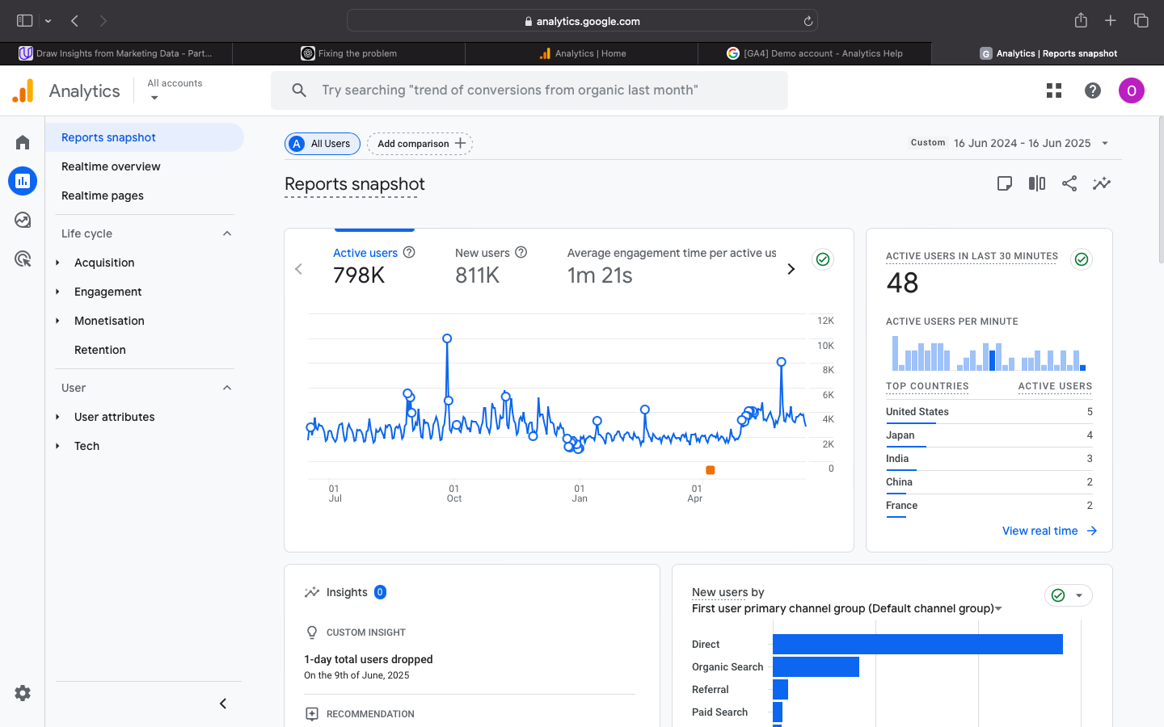

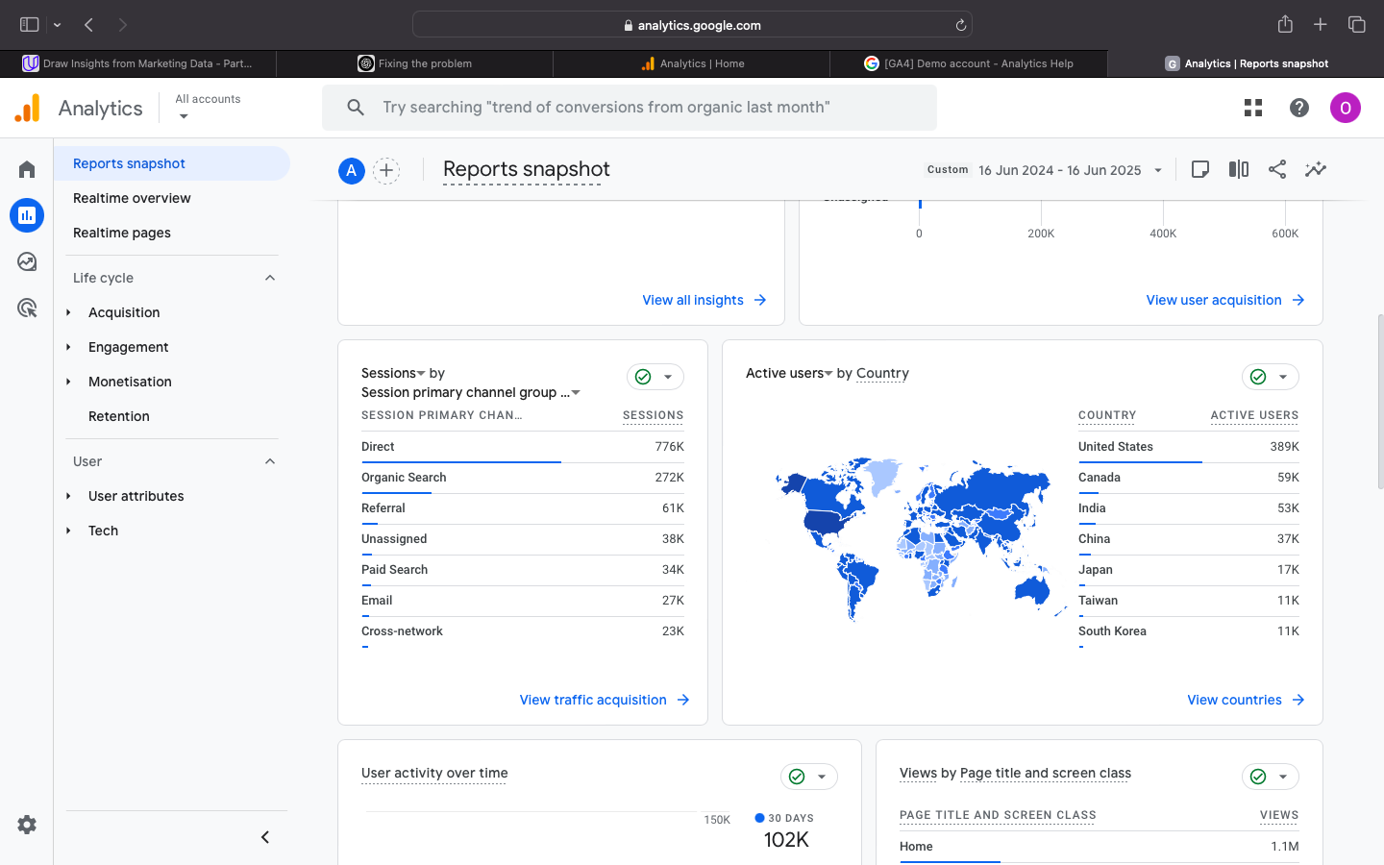

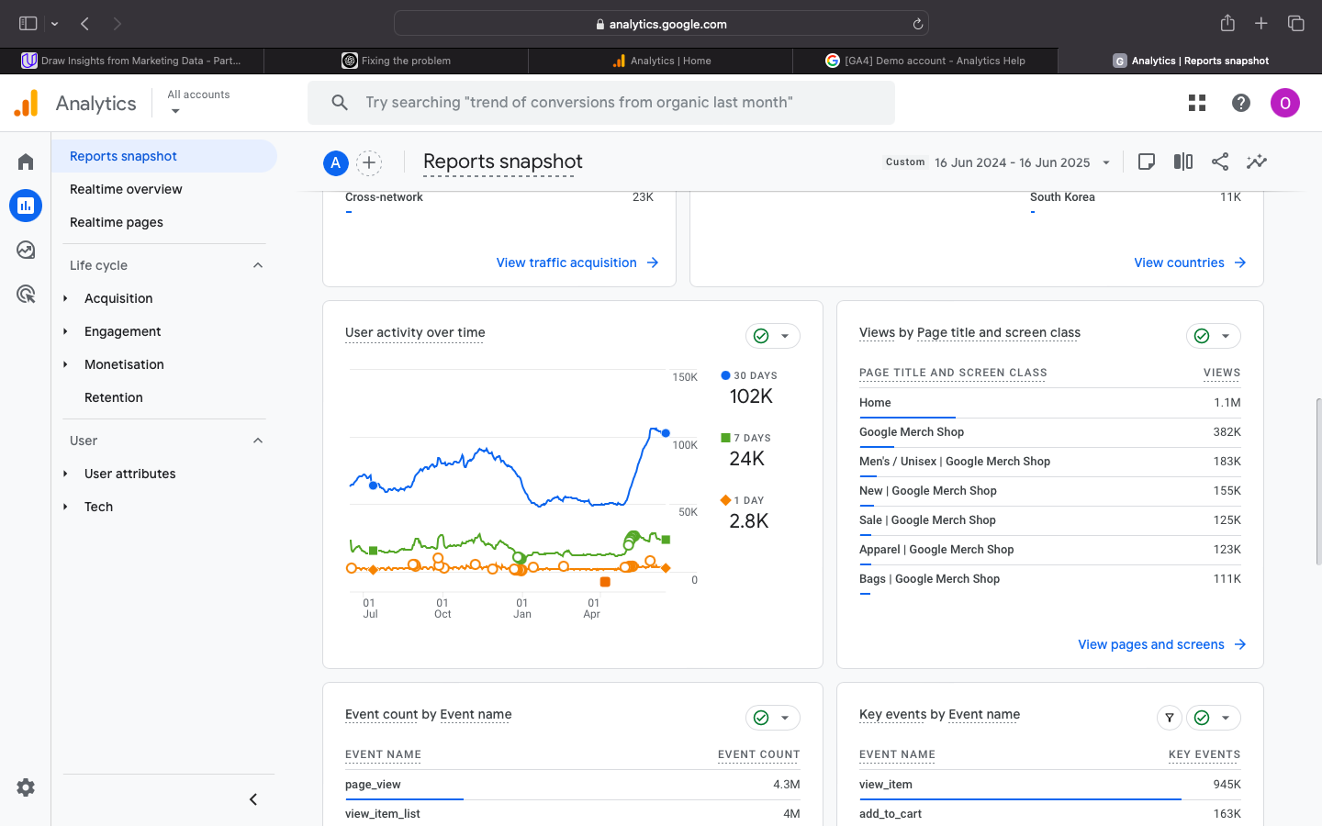

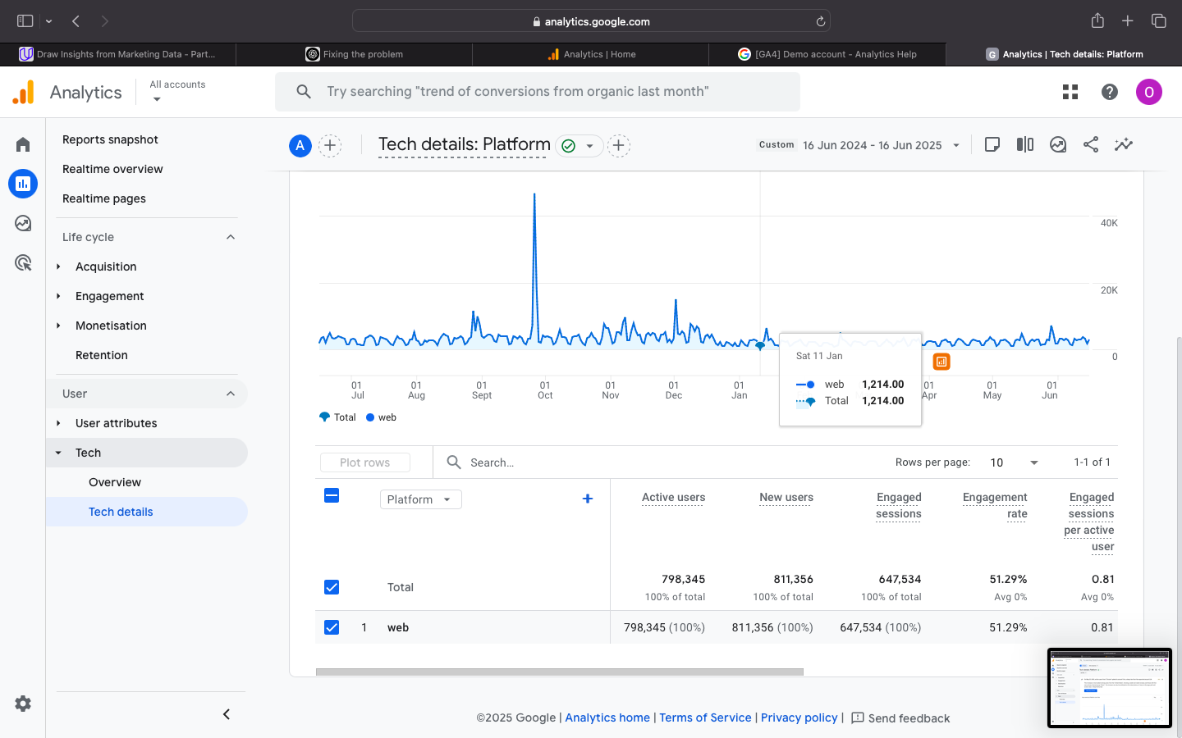

Use Google Analytics reports to answer marketing questions:

Snapshot of Reports Question:

Q: Using the twelve-month timeframe that was chosen, which month saw the greatest number of new users and which the least?  
  
A: Based on the timeline graph that is displayed in the "Reports Snapshot" area:  
Most new users: October 2024, as indicated by the new users chart's highest point.  
Early June 2025 saw the fewest new users; this is indicated by the dip on the chart's far right.

Acquisition of Users Question:

Q: Over the course of the twelve months you have chosen:  
  
Which channel groups' engagement rates were the highest and lowest?  
Which generated the most and the least amount of total revenue?  
What are the meanings of these metrics?

A: (From Tech Details Report) Engagement Rate:

|  |  |
| --- | --- |
| Channel Group | Engagement Rate |
| Highst (Desketop) | 60.55% |
| Lowest (Tablet) | 30.25% |

The reason for this is that desktop users are probably more attentive and involved (longer browsing, simpler navigation), but tablet users might be less involved due to their casual or distracted behavior.

Income by Group of Channels (Source: Monetization Report):

|  |  |
| --- | --- |
| Channel Group | Item Purchases / Revenue |
| Highest Revenue (Email) | Highst avarage value shown in bar chart |
| Lowest Revenue (Organic Search – Cross Network) | Lowest avarage value in the revenue bar chart |

The explanation is that email marketing probably attracts devoted and highly targeted individuals, which improves conversion and purchase tendencies. Although useful for increasing visibility, organic search may not always attract customers who are highly motivated to make a purchase, particularly in the absence of customized landing pages. What These Metrics Mean (My Experience): The engagement rate indicates the degree to which users engage with the website after they arrive. A high rate of engagement (such as from email campaigns or desktop users) indicates that users are navigating through pages, staying on the site longer, and probably converting. This typically occurs when the user experience is more seamless or the material is more pertinent—for example, when desktop navigation is simpler or email campaigns are more specifically targeted. A low engagement rate, on the other hand, (such as from tablet users or organic search) can suggest that users are not finding what they were looking for, are less interested, or are distracted. For instance, a user who discovers the website using a general search term might not be prepared to make a purchase, or the website might not be adapted for mobile devices. Revenue performance by channel also reveals which marketing initiatives are generating real sales. Since email marketing focuses on consumers who are already familiar with the brand and are therefore more likely to make a purchase, it frequently works best. On the other hand, unless the material is extremely optimized, organic search may increase users but decrease their propensity to buy. Marketers can better identify which sources provide important, converting traffic by combining these indicators.

Create segments in Google Analytics:

How I accomplished it (step-by-step):

Section of the Audience by Demographic:  
Guidelines:  
Select a report (such as Reports Snapshot).  
On top, select "Add comparison."  
Select Dimension: Statistics → Gender, Age, or Country.  
As an illustration: Set the segment to "Age = 25-34" or "Country = United States."  
For the comparison to be created, click Apply.

Directions for the Technology Segment:  
Click "Add comparison" from the same or a different report.  
Select a dimension, such as operating system, platform, or device category.  
Set Device Category = Mobile, for instance.  
Press "Apply."

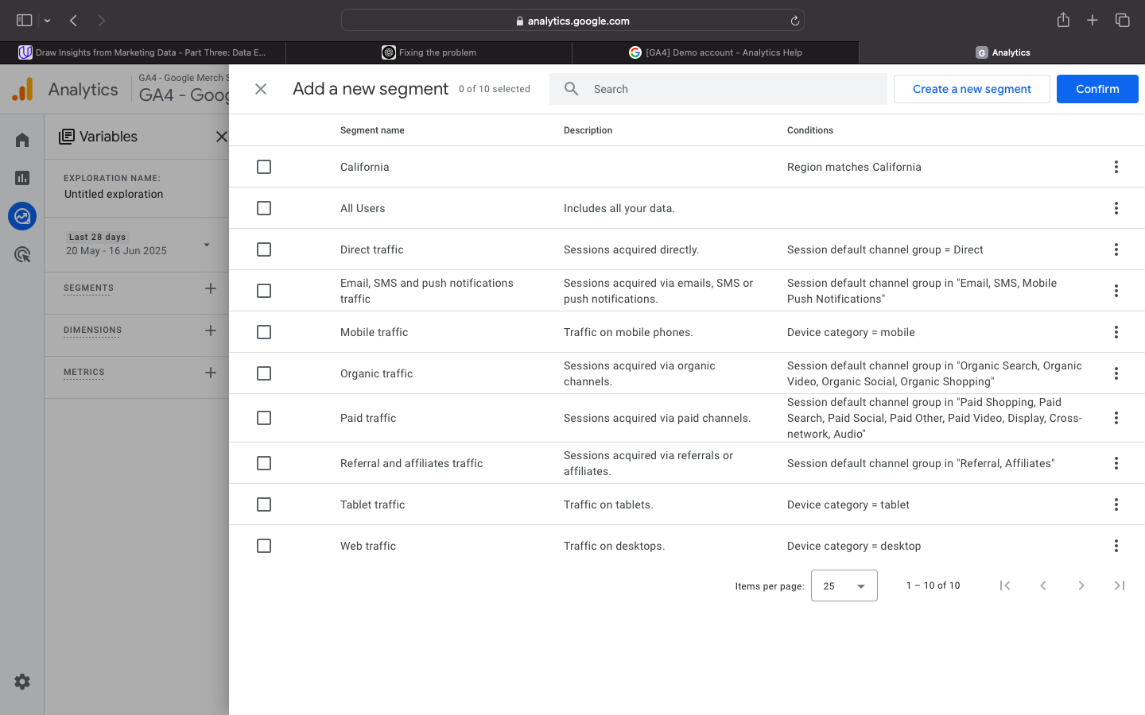

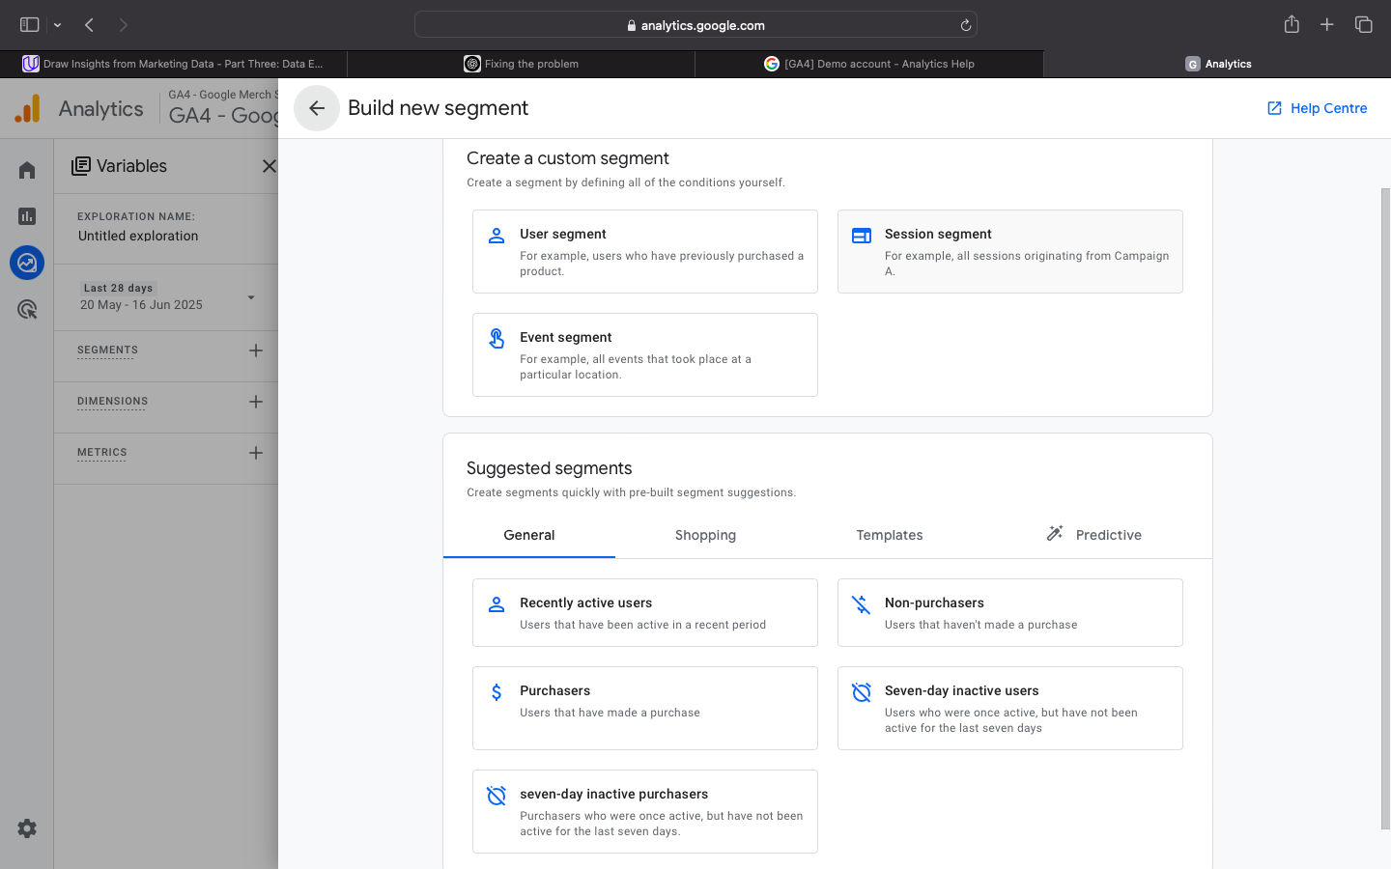

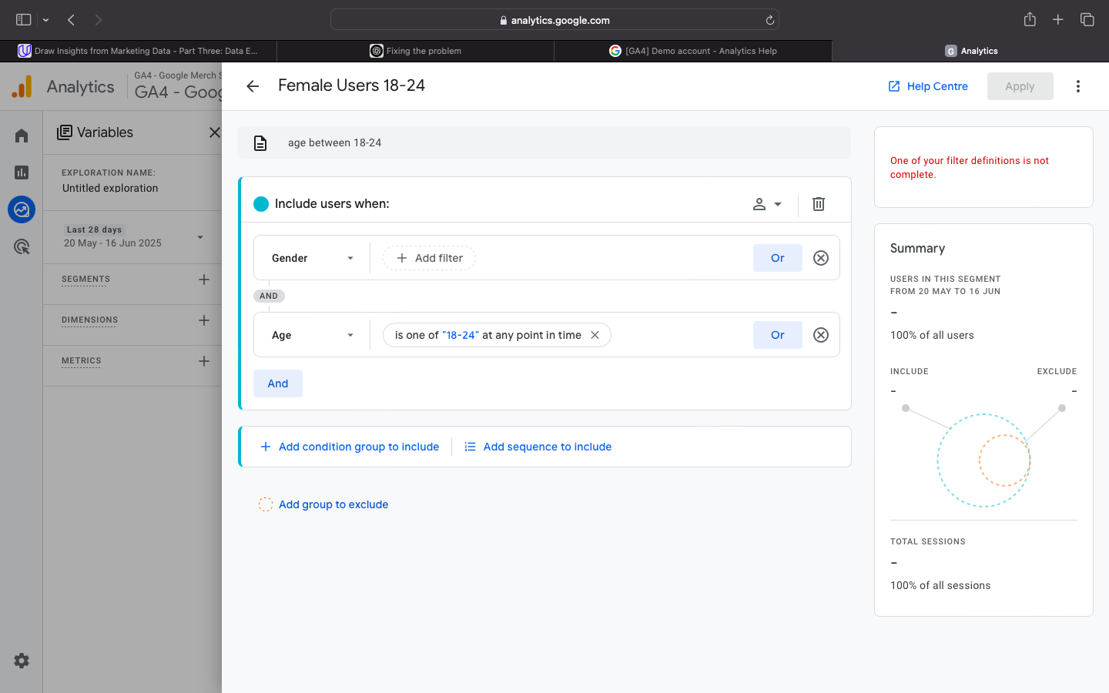

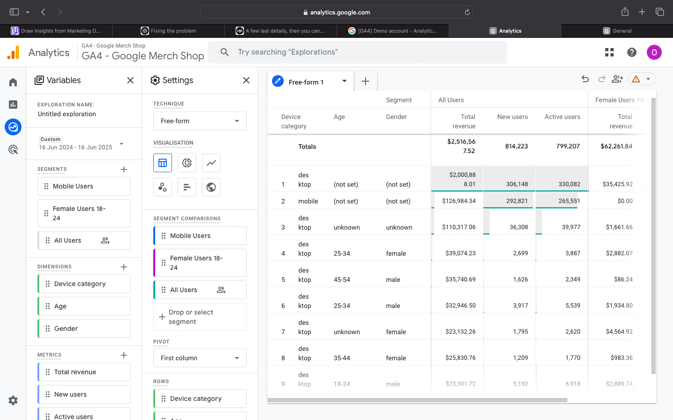

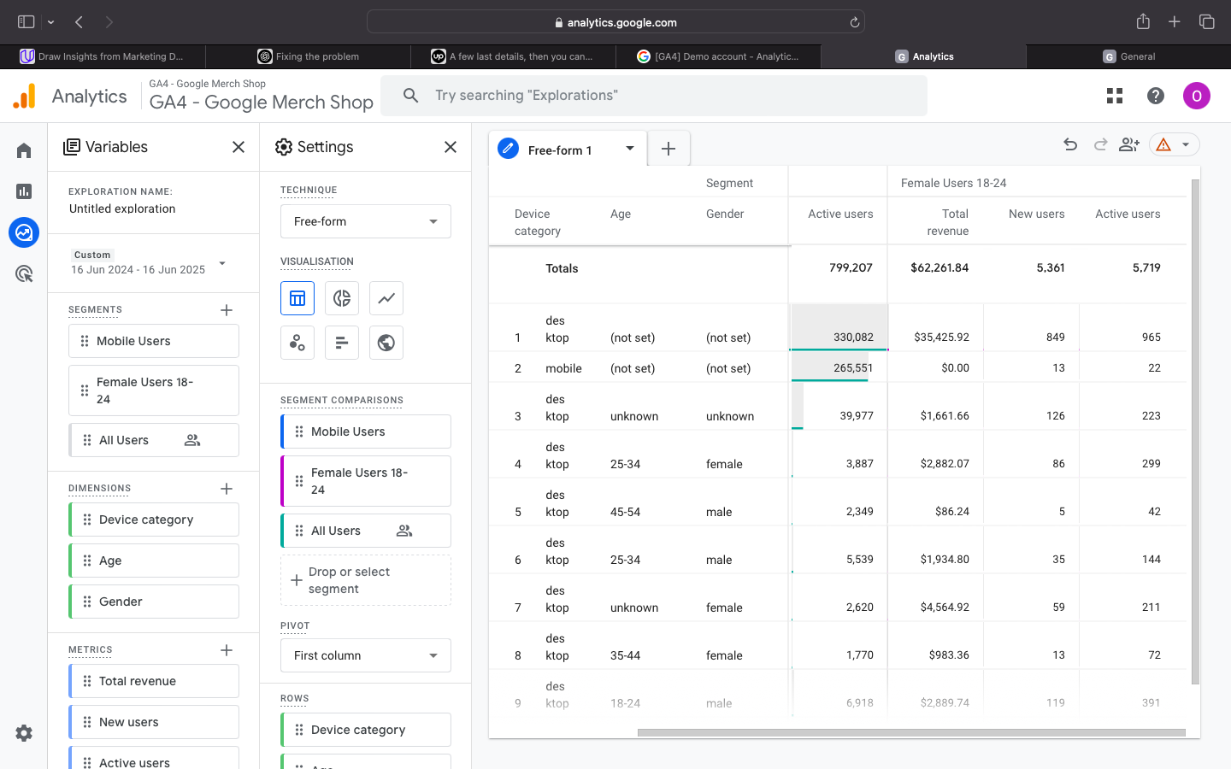

Analysis and Suggestions:

Identify sales growth opportunities:

Determine Opportunities for Sales Growth:  
Based on Google Analytics traffic sources and campaign effectiveness, the following data-driven options are suggested to boost sales income by 20% year over year:  
  
Make Use of High-Converting Channels  
Out of all the channels, email marketing has the greatest average 120-day value, according to the statistics.  
Take action by increasing the frequency of email campaigns that highlight well-liked items (like Pen White and Google Cloud Stickers) and customizing the content with segmented lists.  
Impact anticipated: A substantial boost in revenue growth from a 10–15% increase in recurring business from current clients.

2. Optimize Organic Search Not Just for Traffic But Also for Revenue  
Despite having a low average income per user, organic search generates a lot of traffic (272K sessions).  
Take action: To turn this traffic into sales, enhance SEO landing pages with distinct calls to action, product highlights, and mobile-friendly design.  
A 25% increase in the organic conversion rate is anticipated to raise overall sales without raising expenditure.  
  
3. Use Performance Advertising to Target Mobile Users  
Despite having the lowest engagement rate (42.61%) when compared to desktop (60.55%), mobile accounts for 46.1% of all active users.  
Take action: Start specialized mobile advertising efforts (such social media or Google Ads) that highlight temporary deals and provide mobile-friendly checkout processes.  
Impact anticipated: Increasing the number of mobile visits that result in conversions will assist reach sales targets and boost low-performing engagement.

4. Increase Sales of High-Selling Products Based on the Monetization Report:  
The Google Pen White (5.4K sold) and Google Cloud Sticker (5.9K sold) are the top goods.  
Take action: Develop a campaign centered on best-selling products combined with complementary accessories or seasonal sales (such as gift wraps or back-to-school packages).  
Anticipated effect: Increase sales of tested items with low consumer acquisition costs.  
  
In summary, the store may achieve or surpass 20% year-over-year sales increase by enhancing organic search conversion efficiency, boosting email repeat business, and focusing on high-potential mobile visitors with more effective advertising.

Identify eCommerce improvements:

eCommerce Enhancements  
1. UX Enhancement: Enhance the Mobile Experience  
  
The Tech Details study states that 368,024 users, or 46.1% of all users, are mobile users.  
They do, however, have fewer engaged sessions and a lower engagement rate (42.61%) than PC users (60.55% engagement).  
To decrease friction on mobile devices, it is suggested that mobile sites be made faster, navigation made simpler (e.g., with collapsible menus), and the checkout process streamlined.  
  
Why: This will raise total income and engagement by increasing mobile conversions and leveraging almost half of the traffic.

2. New eCommerce Feature: Allow "Buy Again" or Subscription for The Best-Selling Products  
  
According to the monetization report, products like the Google Pen White (5.4K sold) and Cloud Sticker (5.9K sold) are obviously well-liked and likely to be reordered.  
It is advised to implement a "Buy Again" button or a subscription model for consumable goods (such as notebooks, pens, and stickers).  
  
Why: Without requiring continuous advertising expenditure, this might raise client lifetime value and repeat business.  
  
In summary:  
To improve eCommerce's performance:  
To increase engagement and conversions from almost half of all users, make improvements to the mobile purchasing experience.  
To generate steady, recurring income, offer bestsellers a recurring order feature.

Identify 2 emerging marketing technologies:

Emerging Marketing Technologies 1. Personalization engines driven by AI (e.g., Bloomreach, Dynamic Yield)  
  
Reasons for my selection:  
These platforms utilize machine learning to tailor offers, product recommendations, and website content according to user behavior in real time. This is presenting users with pertinent products based on their past viewing or purchasing history on an e-commerce website such as the Google Merchandise Store.  
  
Benefit: By using customized content distribution, it enhances user experience, raises conversion rates, and raises average order value.

2. Tools for Conversational Marketing (such as ChatGPT-powered bots, Tidio, or Drift)  
  
Why I choose it: These solutions interact with users in real time, respond to their inquiries, and assist them in navigating the sales funnel through the usage of AI-powered chatbots. They can lower cart abandonment and bounce rate by offering immediate assistance and tailored product recommendations.  
  
Benefits include improved customer service, higher engagement, and more leads—particularly beneficial for mobile users or first-time visitors who require prompt responses.  
  
Overview: By integrating conversational marketing and AI personalization into the tech stack, an eCommerce experience that is more intelligent and user-friendly and in line with modern digital consumer behavior may be produced.

The End.

Omnia Al Asfoor.